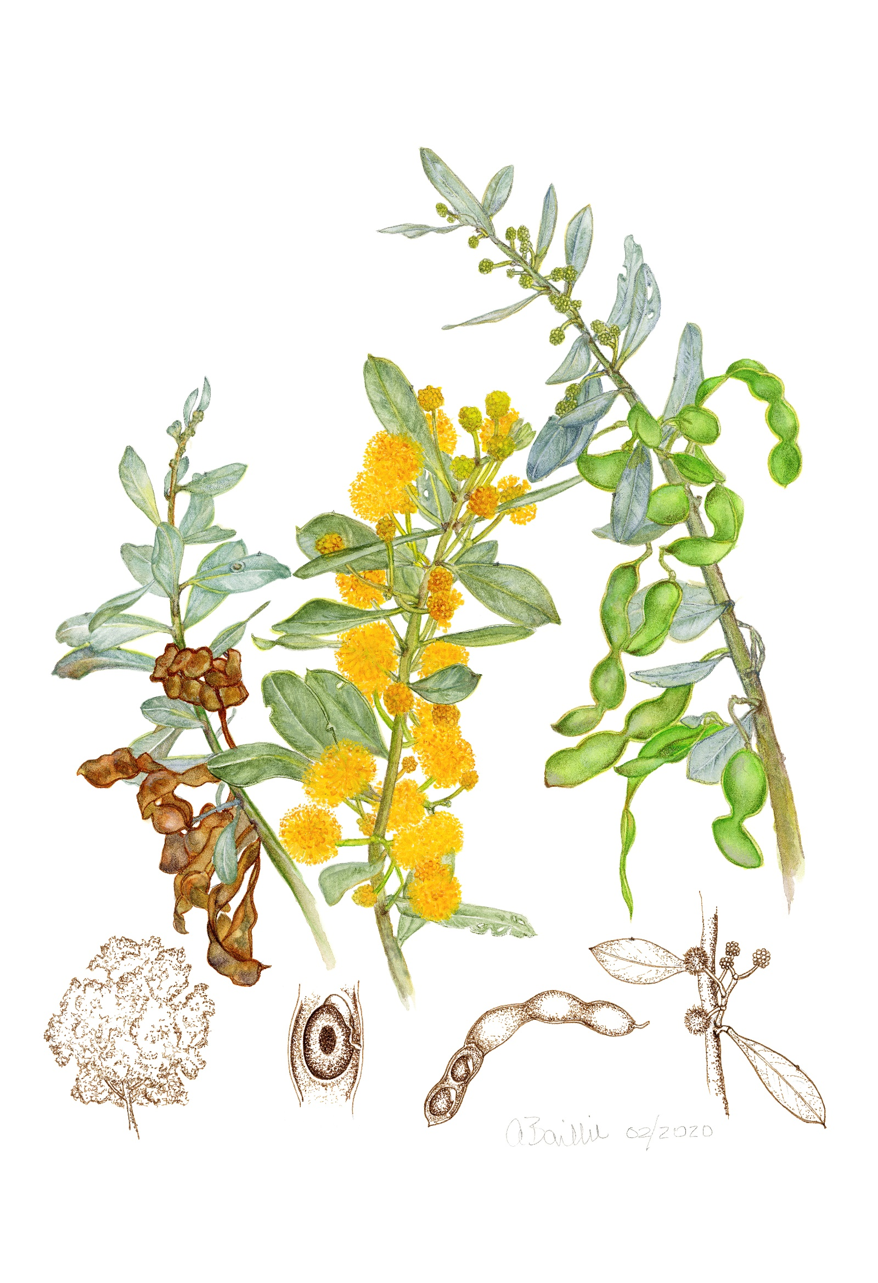
The Acacia Project
Order your copy of this beautiful book today!

Providing illustrations of the twenty-four beautiful and detailed artworks that have been painted by the Whirlies, the Friends of the Royal Botanic Gardens Melbourne Botanical Illustrators, this book documents and depicts some of the rare, endangered and unusual wattle trees or shrubs to be found in the Melbourne Gardens. The original artworks have been donated to the State Botanical Collection along with specimens collected of each species. This book is a tribute to the generosity of talent and goodwill of these skilled artists and the Royal Botanic Gardens Victoria Herbarium team that supported the illustrators endeavours through the two-year project.

All funds raised from sales will be fully donated back to the RBGV Herbarium supporting Acacia research.

Please note all prices include GST.
Title | Cost | Quantity
The Acacia Project book | Friends $25
 | Non-members $30
 |  | Order Sub- Total

Postage/Collection Options
Collect from FRBGM Office | No additional cost to order  Gate Lodge, 100 Birdwood Avenue, Melbourne
Standard postage | $12.50 one copy
 | $25 2-4 copies
 |  | Postage Total
 |  | Grand Total

Customer Details
Name
Street Address
 | Suburb | State | Postcode
Email
Mobile number

Payment Details
Card Number
VISA OR MASTERCARD ONLY
Expiry Date
Name on Card |  | Amount Owing

